1. What is the perimeter of triangle XTG with vertices X(2,6), T(-7,3), and G(-3, -4) in the coordinate plane?
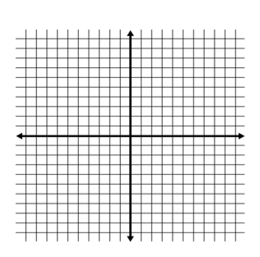

2. A family puts a 8ft x 10ft rug in their family room. There is still 3 feet of floor exposed on all sides of the carpet. What is the perimeter of the family room?

3. The height of a parallelogram is 10in. The base is 14in. When you rotate the parallelogram 90 degrees, the new base is 20in. What is the new height?

4. What is the area of the triangle below?

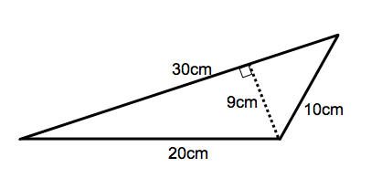

5. What is the area of the triangle below?
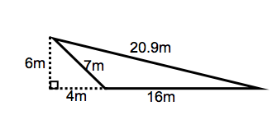

6. Find the area of the rhombus below.

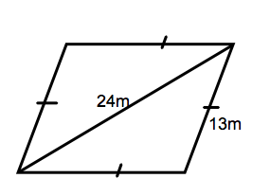

7. Find the area of the kite below.

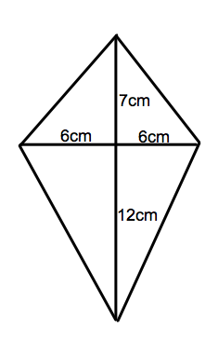

8. What is the perimeter and area of the kite below?
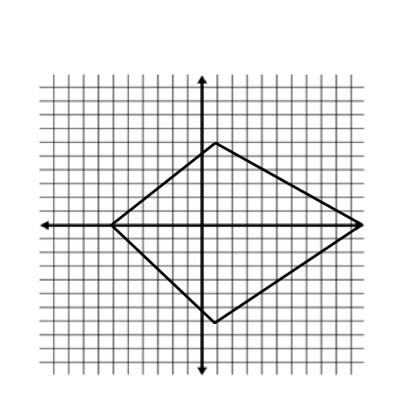

9. What is the area of the trapezoid below?
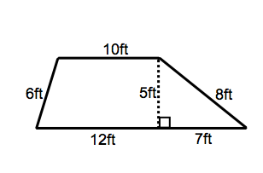
10. What is the most accurate description of the polygon below?
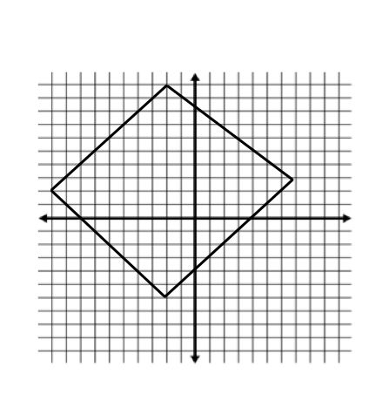
11. What kind of triangle is this?

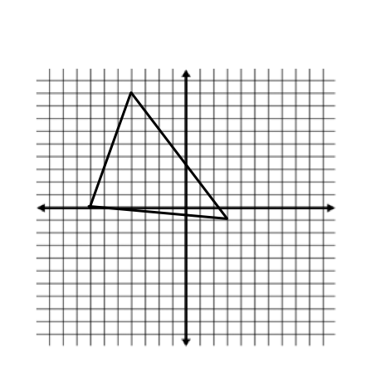

12. Given Z(3,8), what are the coordinates of a rotation of 90º, 180o, and 270º of Z?

13. Write a rule for the transformation below.
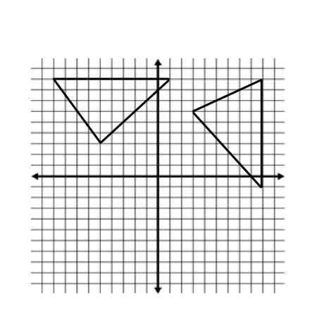

14. The area of a trapezoid is 154cm². The height is 10cm. One of the bases is 16.8cm. What is the measure of the other base?

15. A trapezoid has an area of 139.5m². The height of the trapezoid is 9m and the measure of one base is three times the height. What is the measure of the other base of the trapezoid? (4pts)

16. Find the area and circumference of the circle below.
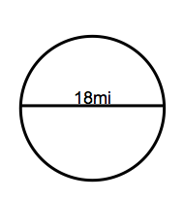

17. Find the missing measures.

A = 153.86 in² A = A =
C= C = 69.08cm C=
d= d = d=
r = r= r= 5ft

18. Find the perimeter and area of the parallelogram below.
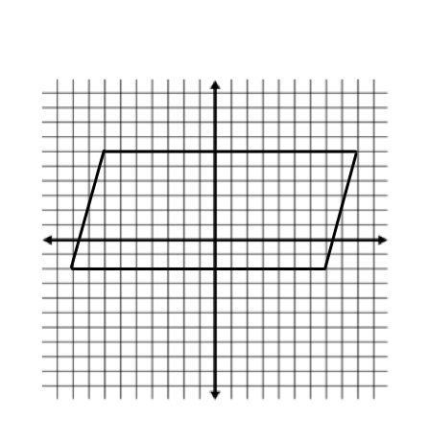
19. Find the area of the figure below.
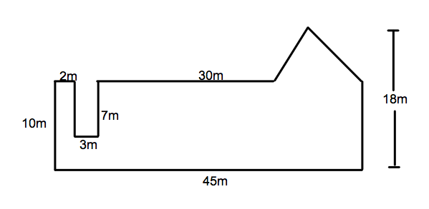

20. What is the perimeter and area of the parallelogram below?
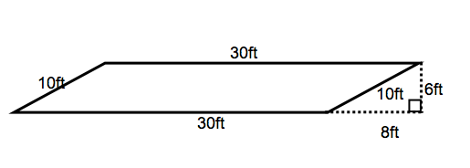

21. What is the most precise name of the figure formed by connection the midpoints of the sides of the parallelogram below?
