1. Find the area of the figure below.

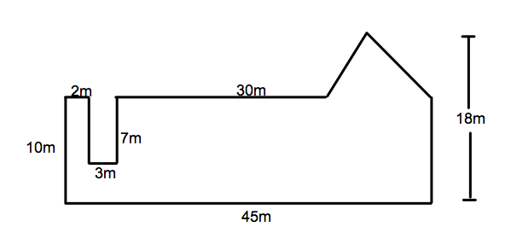
2. What is the area of the triangle below?

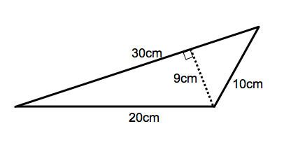

3. What is the area of the triangle below?
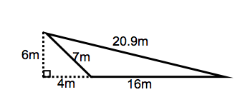

4. Find the area of the trapezoid below.

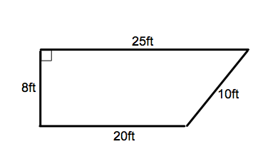

5. The area of a trapezoid is 154cm². The height is 10cm. One of the bases is 16.8cm. What is the measure of the other base?

6. Identify the congruent angles.

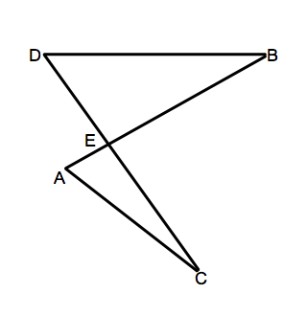

7. Triangles AND and BUT are similar. Find the missing measures.

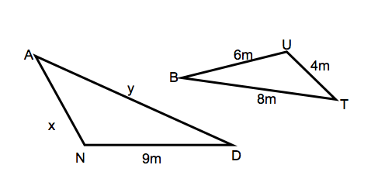
8. Find the missing measures.

A = 153.86 in² A = A =
P= P = 69.08cm P=
d= d = d=
r = r= r= 5ft

9. Find the area and circumference of the circle below.
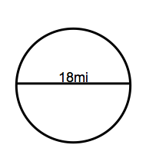

10. The two figures below are similar. Find the value of x.
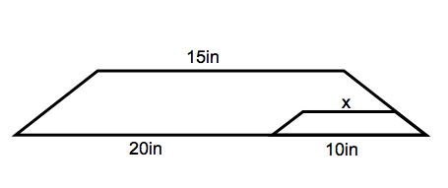

11. The two figures below are similar. Find the value of x.
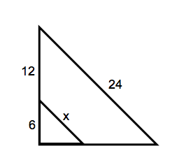

12. What is the measure of <O in the figure below?
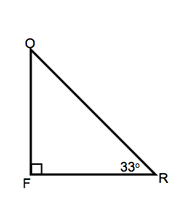

13. In triangle XVT, <X = yº, <V = 2yº, and <T = 3yº. Find the measure of each angle.

14. For the figure below, name the corresponding angles to

<15_________ <12_________ <21__________ <2__________

Name the alternate interior angles to

<17__________ <4___________ <11__________ <1__________

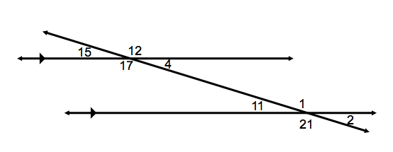
15. In the figure above, if the measure of angle 4 is 40º, what is the measure of the rest of the angles?

<15_________ <12_________ <21__________ <2__________

<17__________ <11__________ <1__________

16. Are lines a and b parallel? Why?

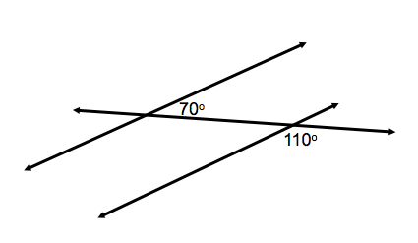

17. Show that the pair of triangles below is similar.
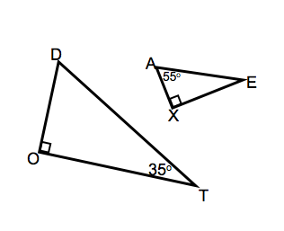

18. Write a similarity statement for the triangles above.

19. What are the three methods for proving that two triangles are congruent?

20. Show that the pair of triangles below is congruent. Explain.

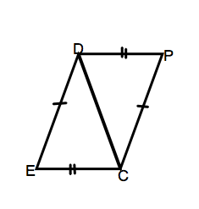

21. Write a congruence statement for the triangles above.

22. The measure of angle 4 is 33º.

What is the measure of its supplement?

What is the measure of its complement?

23. If triangle DRT is congruent to triangle PXY, name all the corresponding parts.

24. In the figure below, what is the measure of AC? How do you know? How can you prove it?
